**ASSIGNMENT 1**

**SYSTEM PROGRAMMING LAB**

**202100102**

**MERWIN PINTO**

**ROLL NO 1**

**DIV E**

**ASM FILE**

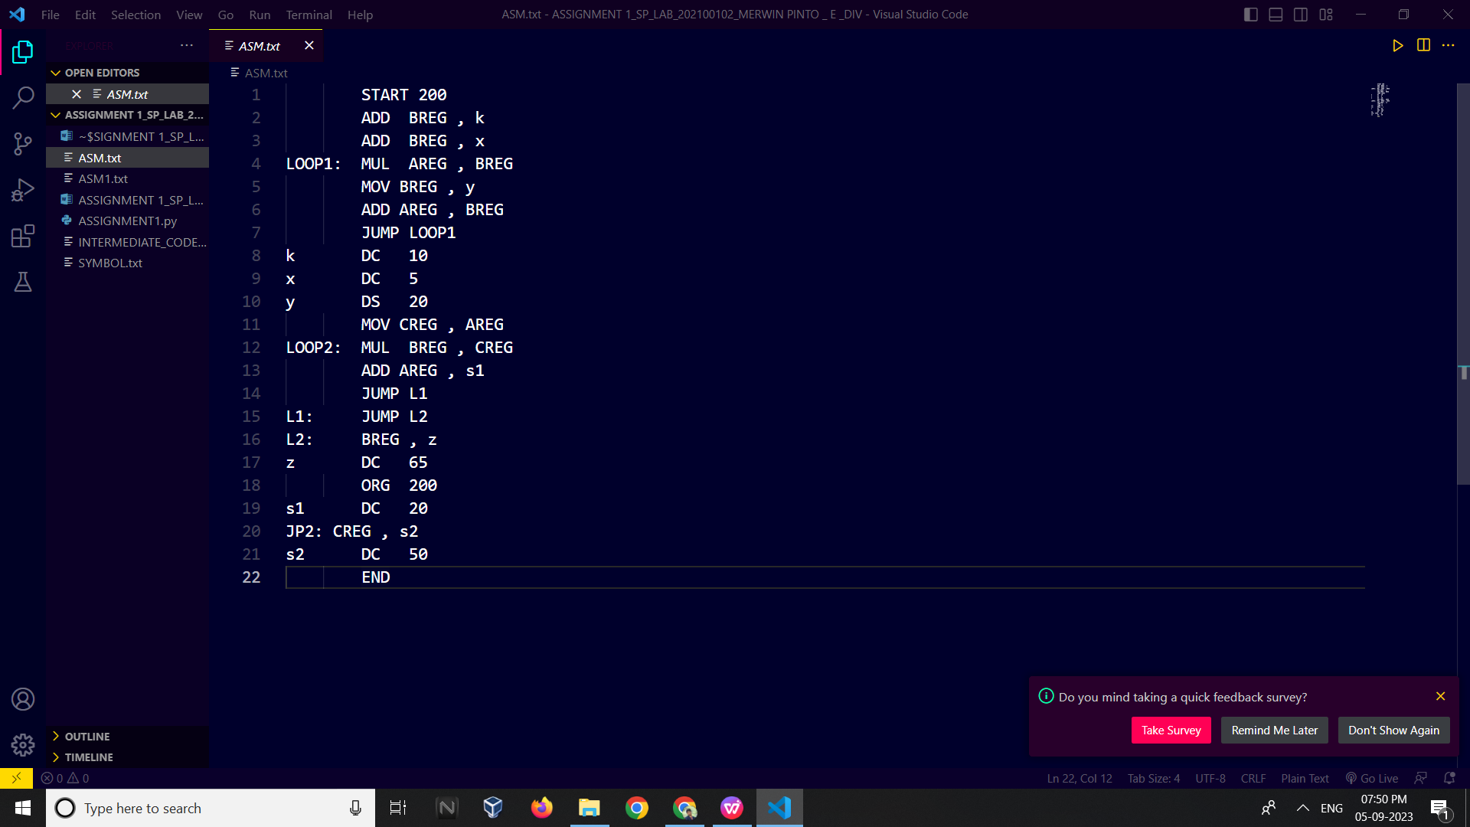

**SYMBOL TABLE GENERATE**

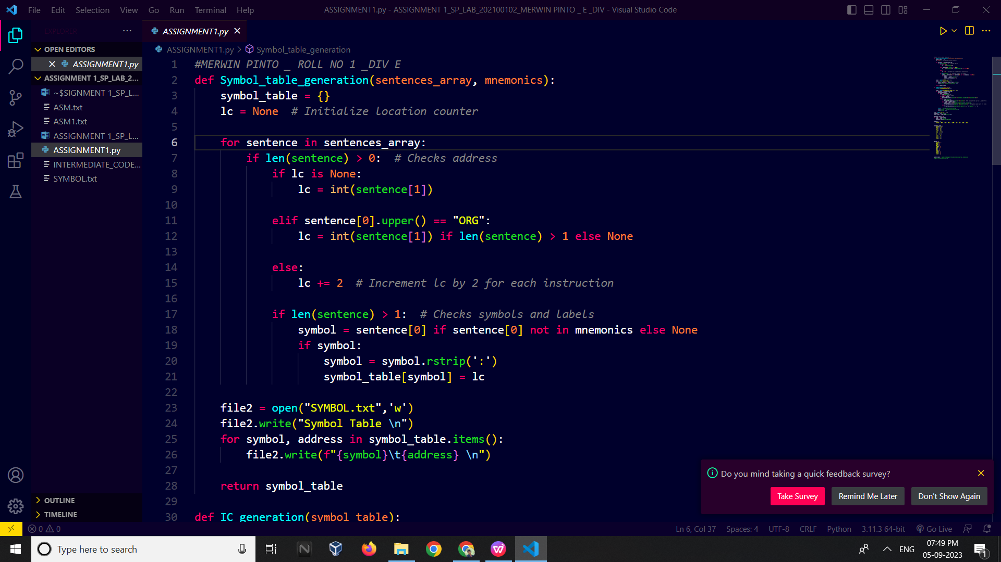

OUTPUT:

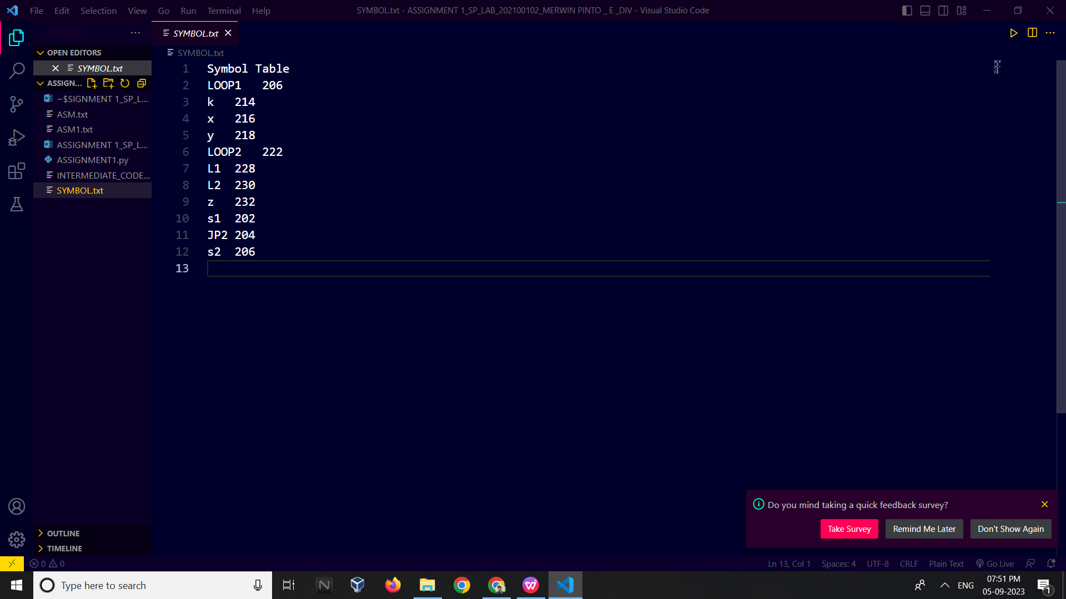

**INTERMEDIATE CODE GENERATION**

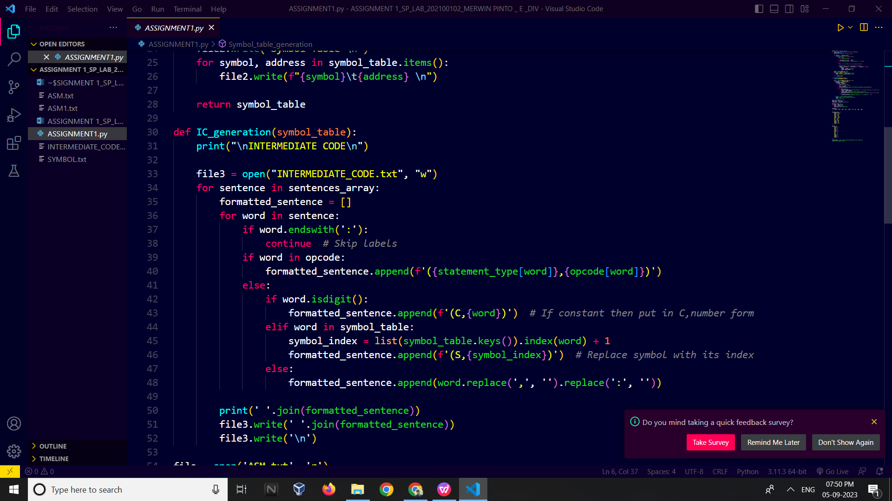

**OUTPUT**

